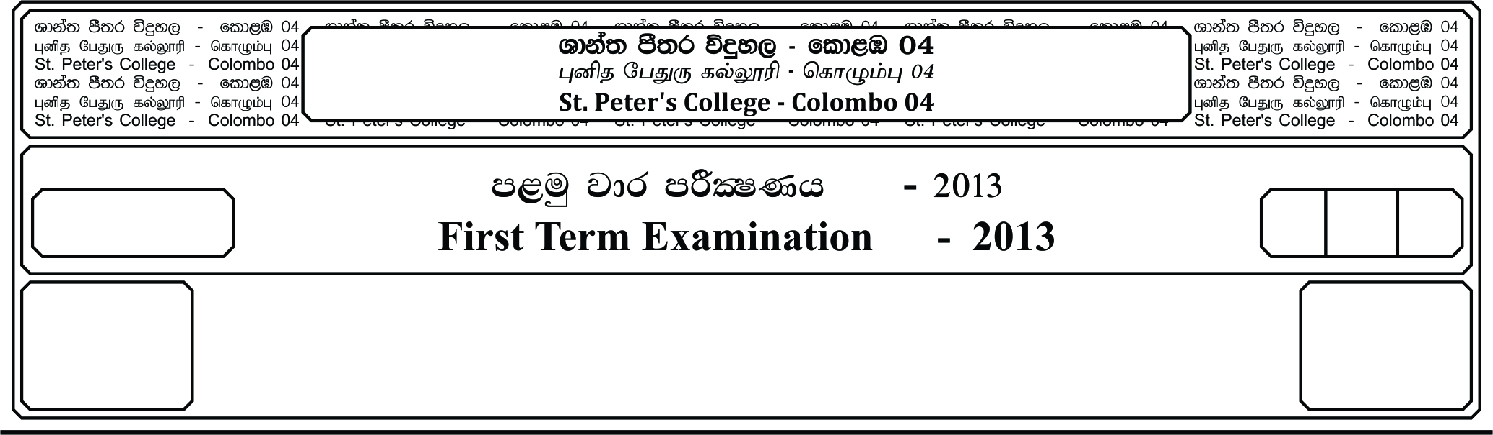

13 fY%aKsh

GRADE 13

E

meh 03

Hour 03

II

**f;jk jdr mÍCIKh - 2021**

**Third Term Examination - 2021**

idudkH bx.%Sis - »»

**GENERAL ENGLISH – II**

❍ **Part A – Reading skills (50 Marks)**

**Question 01**

**Read the passage given below in which some words are given in bold type. Then, underline the meaning that is most appropriate to the context for the words given in bold type from 1-10. (10 Marks)**

Nita was reacently married and had started living with her husband and in-laws. After a few months. She started to realize that she is not able to get along with her **conservative** mother-in-law. Soon they both started quarreling.

Nita became very **aggressive** over the time. As time passes, she started to think that she was obsessed with evil spirits as she had been cursed by her mother-in-law. One day, she found the following advertisement:

“Are you always hated by someone? Do you think that you have evil spirits following you? I have supernatural powers with the use of a special magical powder. This powder has **superb** magical powers. Contact me-Mama Sherine.”

After she had read this, she **rushed** to her father, told him everything that had been happening and asked him to meet Mama Sherine in person. Nita’s father felt pity at her situation but told her that seeking help from such person would be of no use. But, Nita was in no mood to listen and understand. Finally, her father **gave in** and agreed to meet Mama Sherine. Nita was very pleased.

After a few days, her father gave her some powder and told her. “Everyday, just mix a little pinch of this powder in your mother-in-law’s meal. Remember the **quantity** should be very little. Also no one in the house should have **doubt** on you so from today onwards, you should not fight at all with your mother-in-law. Instead, you should be very kind to her, even if she **rude** to you.” Nita agreed and did as advised by father.

As time passed, Nita’s mother-in-law’s nature also started to change. Because Nita was very caring towards her, she too started to be **affectionate** towards her. Five months passed and there were no quarrels. They got **attached** to each other like a mother and daughter.

Nita met her father and told him. “Dad! We must meet Mama Sherine and thank her. Now, my mother-in-law is just like my mom and I love her very much. That powder really has magical powers.” Her father smilled and said, “Which powder? I simply gave you a sweetner! I never met that lady!”

1. **conservative** nature loving traditional democratic cunning

2. **aggressive** upset dominant violent sad

3. **superb** hidden unbelievable mysterious excellent

4. **rushed** called ran met rang

5. **gave** **in** rejected provided revealed agreed

6. **quantity** quality sample amount collection

7. **doubt** debt suspicion trust anger

8. **rude** unkind genuine loyal sympathetic

9. **affectionate** arrogant fond unfriendly cruel

10. **attached** friendly angry impassive remote

**Question 02**

**Read the following letter and answer the questions given below from 1-3 (10 Marks)**

2/155

Talawa Road

Anuradhapura

10th January 2019

My dear Brother Suren,

Thank you very much for the wonderful gift you sent me. I received it **in the nick of time** on my birthday itself. It was indeed very thoughtful of you to have remembered my birthday.i thought that you would forget the day as you are busy with work in your company. Anyway, we all missed you that day.

In the evening, I had a small party at home, where some of my school friends had come over and we thoroughly enjoyed ourselves. Though Supun promised to be there, we missed him as he had fallen off his bike and was taking treatment at home. Our father gave me a beautiful watch. However, the divtionary that you sent me was really useful. I had long wished to buy a new dictionary as the one that I have at present is quite old. The dictionary has a CD and it helps me in **numerous** ways: particularly to cheek pronunciation of words and use it in my computer. As you know, since I am preparing for my GCE A/L Examination this year, with your present I shall be able to do better in my English Language paper.

Thanks again for your **thoughtful** present, which shall always remind me of you. Please give my love to Subashini and aunty Sisiliya.

Your affectionate brother

Mihindu

1. Do the following statements agree with the information given in the above text.

In boxes (a) – (f) write **True** or **False**.

|  |  |
| --- | --- |
| **True** | If the statement is correct |
| **False** | If the statement is wrong |

|  |  |
| --- | --- |
|  |  |
| (a). Mihindu received the present from his brother a few days after his  birthday party. |  |
| (b). Suren is at present employed in a firm. |  |
| (c). Mihindu is happy that Supun joined the party despite his accident. |  |
| (d). At present, Suren has no contacts with Subashini and aunty  Sisiliya. |  |
| (e). Mihindu has a computer and he uses it for studies. |  |
| (f). Mihindu bought a new dictionary as the one he has is very old. |  |

**Statement**

2. Which of the following is **not** given in the text? **Underline** the most appropriate response.

(i). What Mihindu’s father gave him on his birthday.

(ii). What Mihindu’s mother gave him on his birthday.

(iii). The place where the birthday party was held.

(iv). Usefulness of the dictionary for his examination.

3. Underline the option which best expresses the meanings of the words / phrases